Daniel DeCarlo

Box: 107

CIS 331

Prof. Sabal

Final Project

Engineers Notebook

Date: 11/18/19

To begin this project I chose to focus on aquaponics. Before I built anything I researched what aquaponics is and what are some necessary materials to build one. Aquaponics according to [*www.theaquaponicsource.com*](http://www.theaquaponicsource.com) states “Literally speaking, Aquaponics is putting fish to work. It just so happens that the work those fish do (eating and producing waste), is the perfect fertilizer for growing plants. And man, fish can grow a lot of plants when they get to work!”

Aquaponics is like creating a micro ecosystem that produces plant life based off the waste the fish produce and breeding fish.

This link shows what equipment is needed to build an aquaponics farm:

[*https://aquaponics.com/aquaponics-information/build-a-mini-aquaponic-system/*](https://aquaponics.com/aquaponics-information/build-a-mini-aquaponic-system/)

**What You’ll Need**

Following is a list of the parts you’ll need to build a mini aquaponic system. The next section, Component Explanation, describes and explains each of these components and includes recommendations for alternative items and specific products.

* A tank for the fish: 3-20 gallon, glass or plastic container ($10 – $30)
* Gravel: 2.5 lbs. of gravel for every 5 gallons of water in the fish tank ($5 – $15)
* Water pump: 3-4 watt pump capable of lifting 18” – 54” at 30 – 100/gal/hour (small circulation or fountain pump is ideal) ($25 – $50)
* 3 ft. of plastic tubing that fits the outlet on your water pump ($1 – $2)
* Aquarium air pump sized for the number of gallons in your fish tank ($10 – $25)
* Air stone (1” – 3”) ($2 – $10)
* 3 ft. of air tubing to connect the air pump to the air stone (must fit the air pump outlet) ($ 1)
* Grow Bed: must sit on top of fish tank and be 3” – 8” deep ($5 – $20)
* Growing Medium: enough pea gravel, perlite, coconut coir, expanded clay pebbles or peat moss to fill the grow bed ($5 – $10)
* pH test kit and, depending on the pH of your water, pH down or pH up ($10- $50)
* Fish and plants

**What I have:**

* 1.25 Liter breeding tank
* Arduino board
* Water sensor
* Temperature sensor
* Ultra-sonic sensor
* Wires
* Buzzer
* Water

Project Display:

For this project I am thinking of using the materials listed above and replicating to the best of my abilities an aquaponics environment. I will be focusing on the hardware/software side of this project. I will be using the temperature display and the water sensor. I am thinking of using the buzzer to alert if the water level is either medium or low. Below is a sketch of what I think the system should look like.

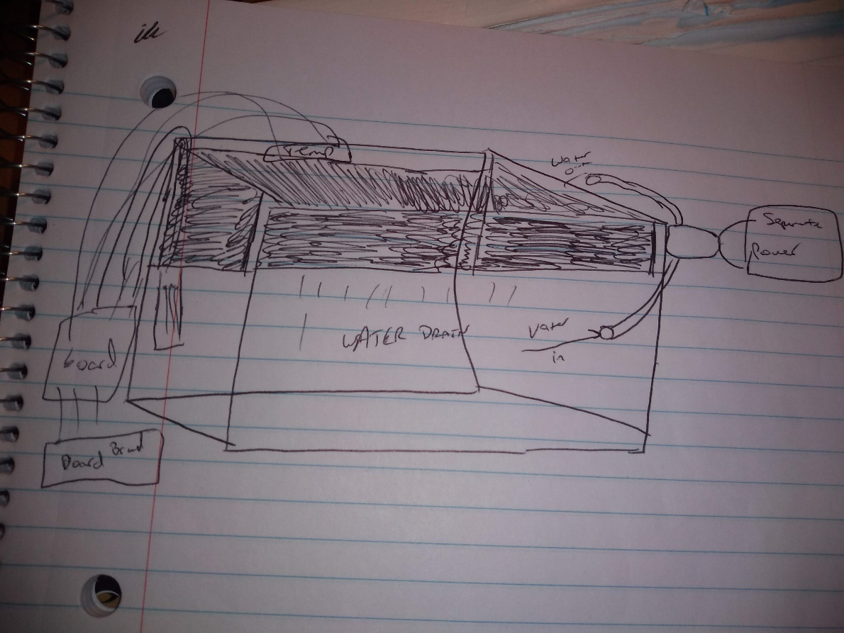

**Watching videos to learn more about aquaponics

Goals: Start to build the system and think about the code.

Date: 11/20/19

Display:

Started to build the bin that fits with tank.

Using an old apple cider container as a way to put plants in.

Drilled holes in the container.

I plan on using the motor in the Arduino kit to make a water pump.

<https://youtu.be/tFNElWDVL1E>

TRY WORKING ON THE CODE NEXT!

Date 11/22/19:

Working on building the motor for the tank.

Using tutorial

<https://www.youtube.com/watch?v=tFNElWDVL1E&t=1s>

I got most of it working but the wire fell off the motor. Now I got to figure out how to put it back on and make sure it works.

Bottle caps are interfering with the blades of the fan. I think I need to use a different base because the Poland spring cap is bent. This is causing the interference.

12/2/19:

Working on the water sensor today. This involves creating the code needed to detect certain water levels. Also I am going to be working on the wiring for the sensor.

The example code from the CD is just generating numbers in the serial monitor and keeps going at a constant rate.

Fixed the problem…I was using the digital pins instead of the analog pins.

I’m trying to figure out a way to print water level is….. Instead of ADC

Moving from water sensor to LED. Using the code from the temperature display project to turn on the LCD. Going to find a way to change display.

Slide one shows Temperature 🡪 slide two shows water level

I have successfully wired the LCD screen and was able to display the different temperatures.

Challenge to this was getting the wiring correct.

I was able to connect the LCD display and the water level sensor to work at the same time on the board. However I was unable to change the alert message on the serial monitor.

ADC%d I tried changing this to water level but, it resulted in an error.

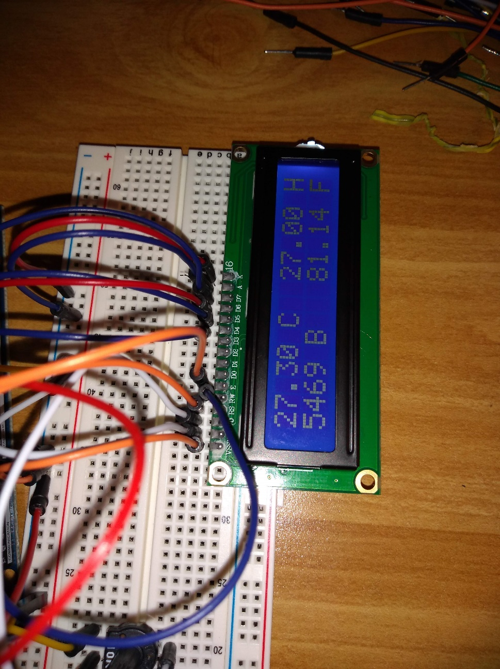

Next step is to figure out how to change the serial monitor message.

Also to display info on LCD.

12/3/19:

Found a way to print water level on the serial monitor. I changed the int ADC to water_level.

I tried this yesterday and found out that there can be no spaces in the code. Also I changed the serial message to water_level%d. Having the %d allows the measurement to take place.

Next goal is to project it on the LCD.

I created a LCD print command and made it print the function printBuffer. This allows the water level value to be displayed on the LCD screen.

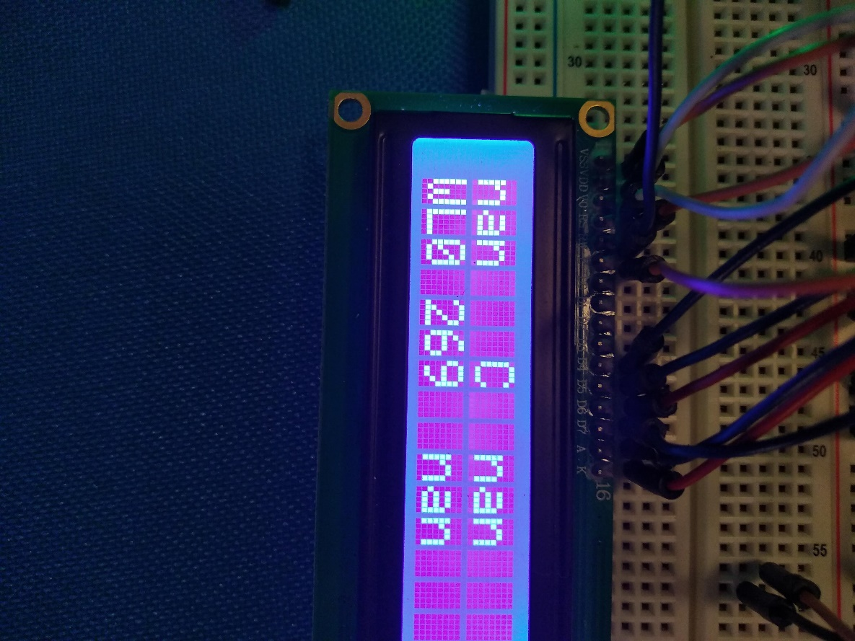

I’m wondering if it would be more convenient to leave all the information on the screen or whether to just make separate screens.

Next Step:

-Create a buzzer that alerts when the water level is too low.

-Fix the motor and make sure that the wires are connected correctly.

Motor:

I found some plastic bottle caps that are more sturdy and straight compared to the Poland spring cap I used earlier. I need to fissure out a way to connect wires to the motor. I need to use the soldering iron to connect the wires. The classroom has one I can use.

Motor is completed…I need to make sure the wires can stay on…that’s where the soldering iron comes in.

How to build the tank?

I’m trying to figure out the best placement for the bread board and the Arduino board. Also I want to make it as neat as possible.

I was able to connect the buzzer to alert when the water level reaches a certain point.

Used the code from the musical instrument and changed the variables in the “if” statements.

I was able to use the if statement to create a new screen that alerts to add more water if the level is less than 150.

The words seem to be mixing up and printing on one screen.

Decided to add a red and green LED. Green means stable, red means unstable.

Used code from the Morse code project and changes port numbers. I added the statements “digital write” with a value of high or low. If the water level is less than 150 then the red light is on while the green stays off.

12/4/19:

LCD is still giving me problems with the display. It fades to the print buffer function then switches to add water. I want to have it project add water and not have the switch. It’s not a major problem it would just make it look nicer.

I added the water sensor to the tank and I am going to try to work on the rest of the tank which includes the temp sensor, and the container.

Also the temperature sensor is giving me NAN values which means the wires are loose or the sensor is broken.

Trying to add the remote. I installed the libraries needed and I need to figure out how the code works.

The youtube tutorial <https://www.youtube.com/watch?v=CZ_mtpyXEFA> explains what to do in an easy way. The code from the example works I have to make sure I can implement it into my final project.

I put the remote coed into my project and it gave me the following code:

Arduino: 1.8.9 (Windows 10), Board: "Arduino/Genuino Mega or Mega 2560, ATmega2560 (Mega 2560)"

Tone.cpp.o (symbol from plugin): In function `timer0_pin_port':

(.text+0x0): multiple definition of `__vector_13'

libraries\IRremote\IRremote.cpp.o (symbol from plugin):(.text+0x0): first defined here

c:/program files (x86)/arduino/hardware/tools/avr/bin/../lib/gcc/avr/5.4.0/../../../../avr/bin/ld.exe: Disabling relaxation: it will not work with multiple definitions

collect2.exe: error: ld returned 1 exit status

exit status 1

Error compiling for board Arduino/Genuino Mega or Mega 2560.

This report would have more information with

"Show verbose output during compilation"

option enabled in File -> Preferences.

12/5/19

I am going to skip the remote and include it if I have time so there is code for the remote commented out.

I need to build the tank. The motor is completed and the temp sensor has been replaced. The motor needs more power in order to push out the water. Also the water isnt being collected by the pump. Might use a external power charger for phones to see if it produces power.

Thinking about making the pump function as a hamster bottle.

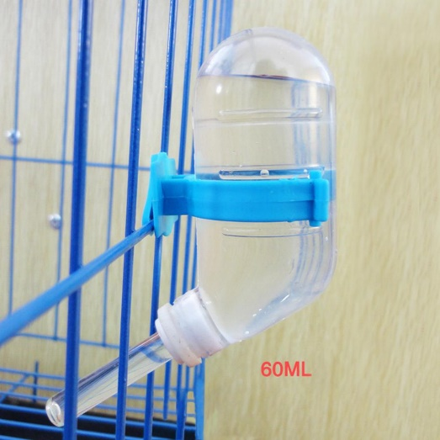

12/8/19

I created the hamster like bottle and completed the physical project. There is some leakage in the motor when water is poured but I’m not going to obsess over it. The water pumps in the container and drains in the tank. The system works, I was unable to find a plant or clay pebbles to put in the container. If this was an advanced system there would be clay pebbles to keep some water for the plant to soak up and the rest drains. Also there is a continuous flow of water from the tank to the container in an actual system, in this I had to use the hamster water system to make the water flow.

Final product:

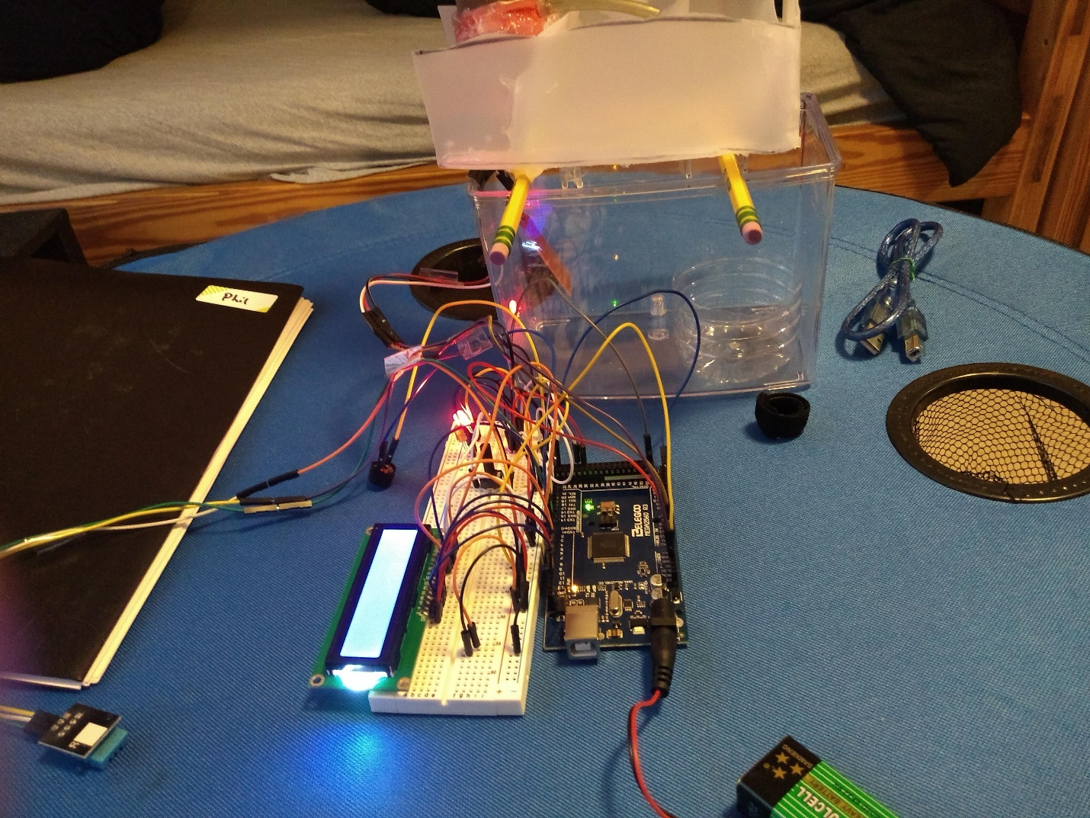

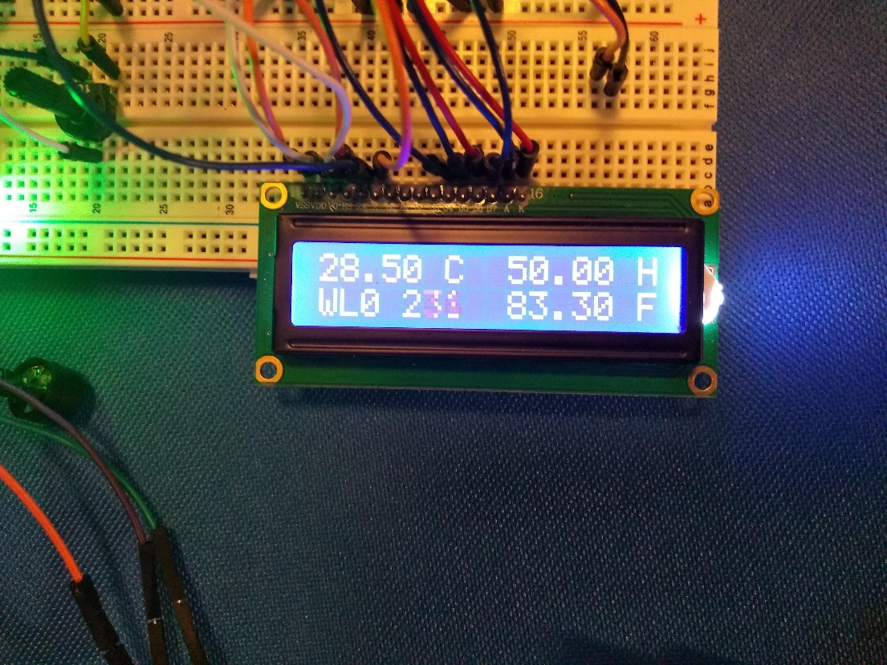

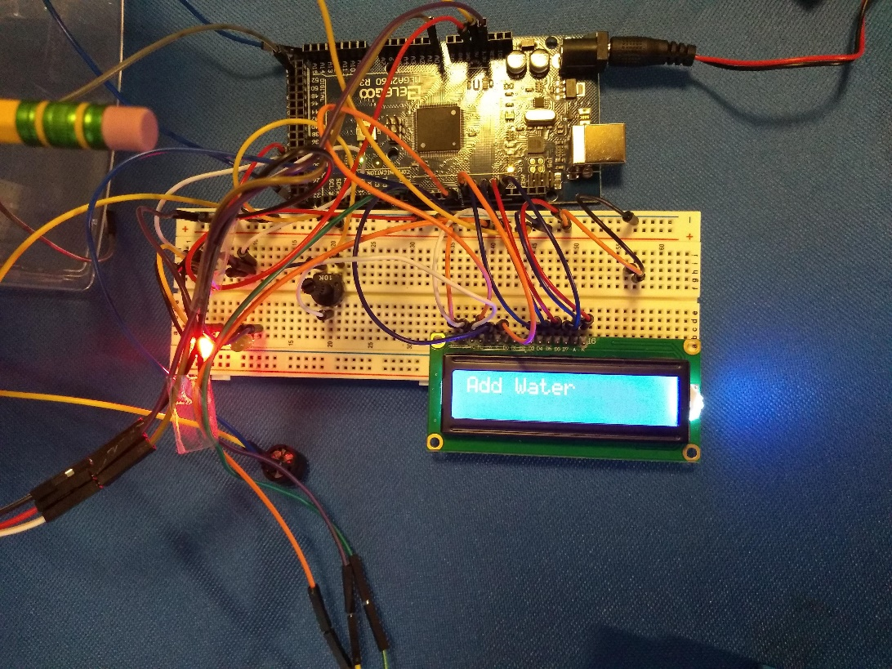

*didn’t want to put water in the tank because of the potential leak becoming worse.